H.T No
Regulations:
A15

Sreenidhi Institute of Science and Technology
(An Autonomous Institution)
Code No: 5C408 Date: 04-Oct-2021(AN)

B.Tech II-Year II- Semester External Examination, Sept/Oct - 2021 (Supplementary)
Electronic Circuit Analysis (ECE)

Time: 3 Hours Max.Marks:75

Note: a) No additional answer sheets will be provided.
b) All sub-parts of a question must be answered at one place only, otherwise it will not be valued.
c) Missing data can be assumed suitably.

ANSWER ANY 5 OUT OF 8 QUESTIONS. EACH QUESTION CARRIES 15 MARKS.

Bloom's Cognitive Levels of Learning (BCLL)

Remember | L1 | Apply | L3 | Evaluate | L5
Understand | L2 | Analyze | L4 | Create | L6

 |  |  | BCLL | CO(s) | Marks
1. | a) | Explain the low frequency response of BJT amplifier. | L2 | CO1 | [8M]
 | b) | The transistor amplifier,shown in the fig,uses a transistor having h-parameters as, V_{cc}=12v, hie=1.1K, h_{fe} =50, h_{oe}=25µA/V, h_{re}=2.5*10⁻⁴. Calculate current gain, input impedance, voltage gain, output impedance.  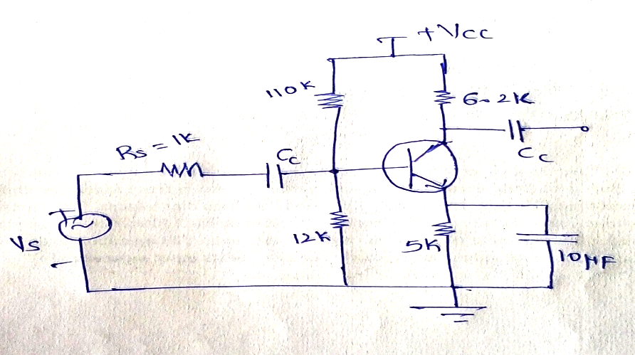 | L4 | CO1 | [7M]
2. | a) | Draw and explain the Common Source stage of MOSFET amplifier. | L1 | CO2 | [8M]
 | b) | Derive the expressions for voltage gain, current gain, input and output resistances of a Common Drain amplifier at high frequencies. | L4 | CO2 | [7M]
3. | a) | Give the block diagram of a general feedback amplifier and state the function of each block. | L2 | CO3 | [8M]
 | b) | Discuss and explain the basic circuit of an RC oscillator and derive the conditions for the oscillations. | L3 | CO3 | [7M]
4. | a) | Find the expression for dc power input, ac power output and maximum efficiency of a direct coupled class A power amplifier. | L5 | CO4 | [8M]
 | b) | In an Ideal Class B push pull amplifier, V_{CC}=20V, N₂=2N₁ and R_{L}=20Ω. Find the output signal power, P_{0max} and collector dissipation in each Transistor, P_{C} under full power condition, Find P_{Cmax} also. | L4 | CO4 | [7M]
5. | a) | Draw the circuit for single tuned capacitance coupled amplifier explain its operation. | L1 | CO5 | [8M]
 | b) | Explain how the stagger–tuned design is superior to synchronously tuned design in the design of a multistage amplifier? | L2 | CO5 | [7M]
6. | a) | What are the various specifications of UPS. | L2 | CO6 | [8M]
 | b) | Draw and explain the block diagram of SMPS. | L1 | CO6 | [7M]
7. | a) | Draw the High frequency model of a Transistor. Derive the relationship between high frequency and low frequency parameters. | L2 | CO1 | [5M]
 | b) | With a neat sketch explain about FET. | L1 | CO2 | [5M]
 | c) | Define frequency and amplitude stability of an oscillator. | L1 | CO3 | [5M]
8. | a) | Why is non-linear distortion called Harmonic distortion. | L2 | CO4 | [5M]
 | b) | Define Q-factor and compare various tuned amplifiers. | L1 | CO5 | [5M]
 | c) | Explain the DC to DC converter. | L2 | CO6 | [5M]

-- 00 -- 00 –

